Equivalent Fractions Practice Questions

1. Show the equivalent fractions for $\frac{1}{5}$ 2. Show the equivalent fractions for $\frac{1}{4}$
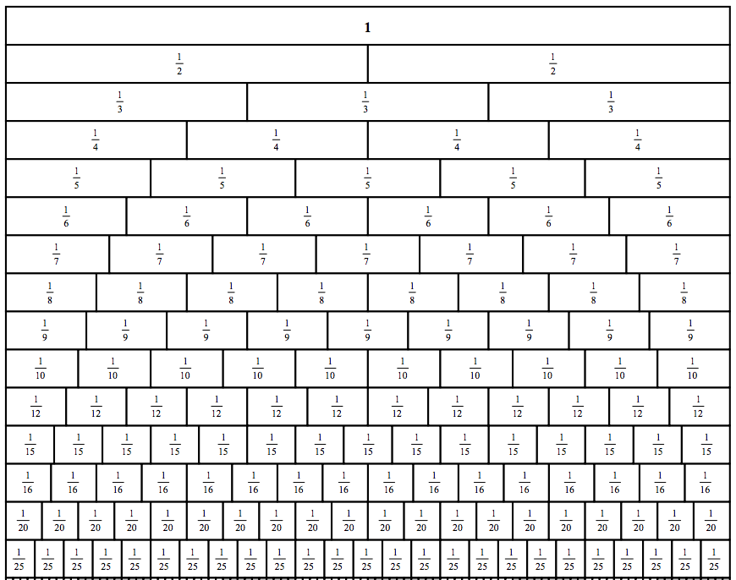
3. Show the equivalent fractions for $\frac{1}{6}$ 4. Show the equivalent fractions for $\frac{2}{9}$
5. Show the equivalent fractions for $\frac{6}{8}$ 6. Show the equivalent fractions for $\frac{3}{12}$

